Pimlico Local Impact Aid
Neighborhood Initiative Competitive Grants
1 Mile Radius
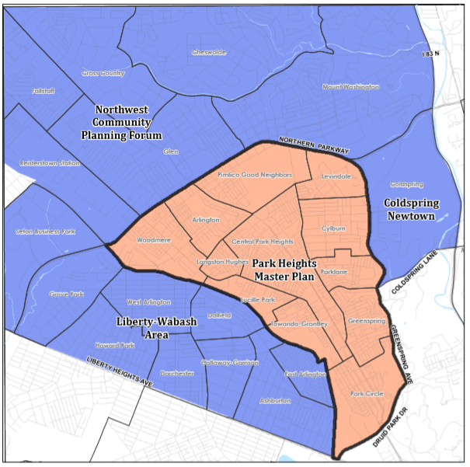
SMALL GRANTS
(Up to $2,500)
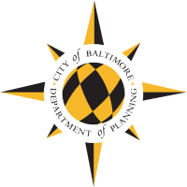
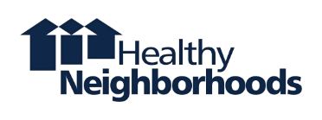
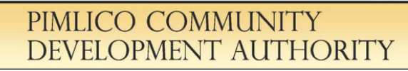

Table of contents
Contents
Useful Information for Applicants 1
Important Dates for Small Grants 1
About this Grant 2
Eligibility Criteria 4
Neighborhood Initiative Competitive Grant Eligible Project Areas 5
Evaluation Process and Criteria 6
Requirements Upon Receiving a Grant 7
Small Grant Application 8
Organization Profile 8
About Your Project 9
Project Budget 10
Project Schedule 10
Other Attachments (optional) 10
Applicant Checklist 11

Useful Information for Applicants

Important Dates for Small Grants
Grant Application Available | Available on PCDA’s website:  https://planning.baltimorecity.gov/pimlico-community-development-authority/funding-resources

Proposal submissions  Small grants proposals are accepted on a rolling basis and will be reviewed by Healthy Neighborhoods, Inc. when they are received. | Submission Date “Rolling Basis”

Notification of Awards  When approved by Healthy Neighborhoods, Inc., small grants will be awarded throughout the year until grant funding is expended. | Notification of awards FY 2022 (all year)

Questions? Please contact Healthy Neighborhoods, Inc. for assistance with your application and project guidance. Healthy Neighborhoods, Inc. is available to assist applicants with developing impactful projects and is maintaining a “help desk” to answer questions.  Completed Application. Please e-mail or mail your completed application to Healthy Neighborhoods, Inc.  Park Heights Master Plan area. For information about funding for the Park Heights Master Plan area, please reach out to Park Heights Renaissance. | Email your completed application to:  Matt Bartolini  mbartolini@healthyneighborhoods.org  410-332-0387 ext. 1004  Or mail your completed application to:  Healthy Neighborhoods Inc.  Attn: Matt Bartolini  11 East Mount Royal Avenue, Suite 302  Baltimore, MD 21202  Park Heights Renaissance  GrantHelp@phrmd.org  410-664-4890

About this Grant

Purpose of Grants: Small grants are available for meaningful projects, community events, and other initiatives that address community needs and desires in the neighborhoods of Northwest Baltimore. To make community-driven projects a reality, funds for small grants are available through Pimlico Local Impact Aid for community building activities.
Grantmaking
Partnership: This grant is made possible through a partnership between the City of Baltimore, Pimlico Community Development Authority, and Healthy Neighborhoods, Inc.
- City of Baltimore – The City receives Pimlico local impact aid to be spent within the eligible areas. The final approval for grant awards is from the Mayor’s office.
- Pimlico Community Development Authority (PCDA): PCDA serves an advisory role in determining funding allocations for Local Impact Aid funding. PCDA has the responsibility to advise the Mayor on priorities and the final funding decisions are part of the City budget approval by the Mayor and City Council.
- Healthy Neighborhoods, Inc. Healthy Neighborhoods Inc. assists strong but undervalued Baltimore neighborhoods increase home values, market their communities, create high standards for property improvements, and forge strong connections among neighbors. Healthy Neighborhoods, Inc. is the City’s grant management partner and is available to assist with grant applications; grant agreements; technical assistance; fiscal agents; and meeting city requirements such as insurance.

Source of Funds: As a result of the legislation authorizing casinos in Maryland, the City of Baltimore receives Video Lottery Terminals revenue (Local Impact Aid) dedicated for areas around Pimlico Racetrack through 2032. The Local Impact Aid is allocated through an annual Spending Plan. In FY2022, funding was made available for neighborhood initiative competitive grants.

Grant Amount: Eligible applicants can use this application to request up to $2,500 to implement various community initiatives. For larger projects, please use the Large Grants application (available on PCDA’s website). The small grants application has fewer criteria than the large grants application and is very flexible.
Applicants may apply for both Large Grants and Small Grants, but no organization, its subsidiaries, or affiliates can receive more than 3 Pimlico Local Impact Aid grants and/or $35,000 in a fiscal year and/or concurrently. If you are applying for grants in FY22, you must have completed prior grant activities.

Grant Conditions: If you are applying for additional grant funding, you must have completed prior grant activities.

Projects located on property owned by the Baltimore City’s Department of Recreation and Parks (BCRP) will require BCRP approval prior to award. BCRP requires all applicants to complete the Intent to Apply Form (included on PCDA’s website) at least two weeks in advance, as that is the time it takes to review and approve proposals. BCRP’s letter of approval must be attached to the grant application and submitted prior to application deadline.

Use of grant: The Pimlico Local Impact Aid Small Grants are available for projects that address various community interests, events, and causes. Grants are available to help neighbors and community organizations enhance their communities and implement community priorities that benefit residents of all ages. This funding will help neighborhoods be welcoming, safe, and vibrant places.
Examples of suitable projects include:
- Arts activities and music festivals
- Culinary arts classes
- Neighborhood and community events
- Beautification and marketing efforts
- Organizing a community garden and tree planting
- Educational opportunities such as STEM activities that benefit youth
- Community signs
- Financial empowerment training
Funds would also be available to community associations in need of technical assistance or expert help for a particular issue facing the community, such as professional design, financial, or legal services to address specific community challenges or opportunities; assistance to secure 501c3 status; or development of a strategic plan for a community organization.

Eligibility Criteria

Eligible Areas: Three areas within Northwest Baltimore are eligible to receive these grants (see map on next page). $168,000 is available for the 1 Mile Radius Areas: Northwest Community Planning Forum Snap areas; the Liberty-Wabash area; and the Coldspring-Newtown area. Of the FY22 neighborhood initiative grant funds, 50% of funds are reserved for the Liberty-Wabash communities.
- Liberty-Wabash area: Liberty Heights Avenue (S), Northern Parkway (W), Wabash (N/E)
- Northwest Community Planning Forum SNAP area: Northern Parkway (S), County line (W/N), Jones Falls Expressway (E)
- Coldspring-Newtown area: Northern Parkway (N), Greenspring Avenue (W), West Cold Spring Lane (S), Jones Falls Expressway (E)
Applicants must be based in the eligible areas, work in those neighborhoods, or partner with an organization based in those neighborhoods.

Eligible Applicants: In order to be eligible, applicants must be one of the following:
- A non-profit organization with 501(c)3 tax-exempt status that is recognized by the IRS.
- A mission-based organization without 501(c)3 tax exempt status but with a 501(c)3 fiscal sponsor.
- A faith-based organization proposing a non-religious project that benefits the public.
- Public Schools proposing a project that benefits its students.
Individuals and for-profit businesses may not apply.
Fiscal Requirements: To be eligible, applicants must meet the following fiscal requirements:
- Fiscal sponsor. A fiscal sponsor with tax exempt status will be required to manage any awarded grant funds for applicants that do not have an IRS Determination Letter.
- For those not able to receive funds directly, direct payment to vendors will also be considered.
- Tax ID number. Organizations must have an active tax identification number.
- Bank Account. Applicants or fiscal sponsors must have a valid bank account in the name of the organization.

Neighborhood Initiative Competitive Grant Eligible Project Areas – 1 Mile Radius
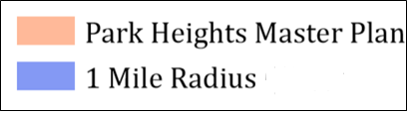

Evaluation Process and Criteria
Small grant applications will be reviewed and approved by Healthy Neighborhoods, Inc. (HNI). HNI’s recommendations for funding are also shared with the Director of Planning/PCDA Chair. Applications will be evaluated based on the date of their submission and can be submitted at any time. To ensure fairness, the criteria below is used to evaluate applications.

Priority:
Projects creating visible, physical change (e.g. capital projects) will be given priority.

Scoring Criteria:
- Readiness
- Well thought out proposal
- Number of residents who benefit
- Organizational Capacity and Experience
- Resident Participation and Leadership
- Clearly defined project budget with supporting documentation
- Value and total cost of the project

Successful applications will:
- Be complete and follow application guidelines
- Demonstrate resident participation in the planning, implementation, and leadership of the project
- Create positive community action
- Show careful planning and complete budgets
- Reflect the neighborhood’s ability to implement the proposed project
- Build partnerships with residents, community-based organizations, schools, local institutions, local merchants or others

Requirements Upon Receiving a Grant
If your project is funded, it will be subject to the following requirements:
- Grant Agreement. You will need to prepare and sign a Grant Agreement describing the project and detailing the roles and requirements of all parties BEFORE the project begins.
  - Final Scope and Budget. The Grant Agreement will include a final detailed scope of work, and a final budget. It will also include a projected draw schedule, which can be updated over time.
  - Certificate of good standing. Applicants must provide a Certificate from the State of Maryland. The online copy is free and acceptable.
  - Insurance. Baltimore City and/or Healthy Neighborhoods, Inc. may require project insurance.
- Payment Procedures: Healthy Neighborhoods, Inc. will not pay for the full project upfront. Healthy Neighborhoods, Inc. will either reimburse you (or your fiscal sponsor) for expenses as they occur, or directly pay a vendor on your behalf. No future draw requests will be considered until all previous draws are accounted for with payment documentation (i.e., receipts).
- Payment Documentation: At the completion of any awarded project all payment documentation must be submitted to Healthy Neighborhoods, Inc. within 60 days from the day of completion. All organizations affiliated with a project that doesn’t have sufficient documentation for all expenditures within the 60 day timeframe will be prohibited from receiving any future grant funds available through Pimlico Local Impact Aid.
- Reporting: Grant recipients are required to submit reports and photos highlighting their efforts, to make sure that the funds are used as intended. Final payment will be held until a report is submitted.

Small Grant Application

Please select the geographic area of your grant request:
☐ Coldspring Newtown ☐ Liberty-Wabash ☐ NW Community Planning Forum SNAP

Please select each of the following that apply:

I/we understand that individuals or for-profit business may not apply. I/we represent the following (mark all that apply):
☐ 501 (c) (3) non-profit ☐ Neighborhood Association ☐ Community Organization
☐ Faith-based organization ☐ Public or Charter School ☐ Parent Teacher Organization
☐ Government Agency ☐ Other (please specify):

ORGANIZATION PROFILE

Organization Name:
Tax ID Number:
Organization Address:
Organization Phone:
Organization Website: (if applicable)
Primary Contact Required
Name:
Title:
Phone:
Email:
Secondary Contact Required (Non-Relative)
Name:
Title:
Phone:
Email:
Fiscal Sponsor Contact (If applicable)
Organization Name:
Tax ID Number:
Contact Name & Title:
Organization Phone:

About Your Project

Project name: _______________________________________________________________

Amount requested: $______________ Total project budget: $_______________
(Maximum request = $2,500)

Start and end dates of the proposed project: Start ___________ End _____________

Project Location(s): _______________________________________________________

In what specific neighborhood(s) is your project located? _________________________

Briefly answer the following questions (maximum 3 additional pages, 12 pt. font):

- Briefly describe your organization’s history and mission, the vision it is working toward, and goals to get there.

- Please describe your project. What specific issue/challenge do you want to address? Why is this request a priority for your community at this time?

- Describe in detail the project for which your organization is seeking funds. Describe the activities to be undertaken. Who is leading this project? Who is involved? How many adults/youth took part in the planning of the project? Describe the process by which your organization chose this project to address the issue/challenge named in question B.

- Is this a one-time project or an annual project? Is this a new project for your organization or something you have done before? If it has been done before, what impact has it made?

- For this project, what does success look like? How will you measure this success? How many people will benefit?

Project Budget

List each item in the budget and include the activity and the cost. Please attach a copy of the quote for each item. It can be printed directly from a website or a formal quote.

No more than 10% of the total grant award can be used for administrative costs or fees.

Item | Activity | Cost
Example: 30 bags of mulch | Place around new garden beds | $105.00
1.

2.

3.

4.

Project Schedule

List each project milestone and include the relevant timeline.

Milestone | Timeline
Example: Secure venue | 4 weeks
1.

2.

3.

4.

Other Attachments (optional)

You may submit letters of support, recent newspaper/magazine articles, promotional materials, photographs, and other relevant information not requested above. Please be selective in providing additional attachments.

Applicant Checklist

Application requirements
☐ Geographic Area selection
☐ Organizational Profile (Contact information, tax ID number, and fiscal sponsor if applicable)
☐ About Your Project (name, timeline, location, neighborhood, and questions)
☐ Project Budget
☐ Project Schedule
☐ If applicable, Baltimore City Recreation and Park’s Intent to Apply Form (pg. 3 of application)

Other Attachments (optional)
☐ Other attachments, including letters of support, recent newspaper/magazine articles, promotional materials, photographs, and other relevant information not requested in the application.

Applications should be returned to Healthy Neighborhoods, Inc.

Email your completed application and all attachments to:
Matt Bartolini
mbartolini@healthyneighborhoods.org
410-332-0387 ext. 1004

Mark Sissman
msissman@healthyneighborhoods.org
410-332-0387 ext. 1001

Or mail your completed application and all attachments to:
Healthy Neighborhoods, Inc.
Attn: Matthew Bartolini
11 East Mount Royal Avenue, Suite 302
Baltimore, MD 21202

