Pimlico Local Impact Aid
Neighborhood Initiative Competitive Grants
1 Mile Radius
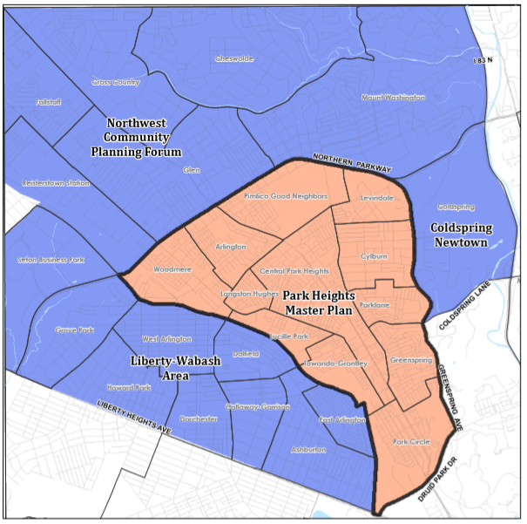
LARGE GRANTS
($2,500-$30,000)
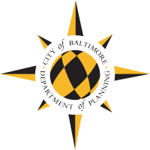
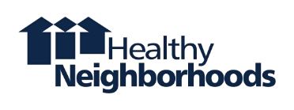
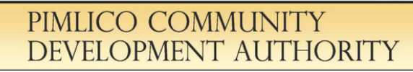

Table of contents
Contents
Useful Information for Applicants 1
Important Dates for Large Grants 1
About this Grant 2
Eligibility Criteria 4
Neighborhood Initiative Competitive Grant Eligible Project Areas 5
Evaluation Process and Criteria 6
Requirements Upon Receiving a Grant 7
Large Grant Application 8
Please select the geographic area of your grant request: 8
About Your Project 9
Project Budget 10
Project Schedule 10
Board Resolution 11
Letters of Support 11
Bonus Points (optional) 12
LEVERAGE 12
PARTNERSHIPS 13
STRATEGIC PLAN 13
OTHER ATTACHMENTS (optional) 13
Applicant Checklist 14

Useful Information for Applicants

Important Dates for Large Grants
Grant Application Available | Available on PCDA’s website:  https://planning.baltimorecity.gov/pimlico-community-development-authority/funding-resources

Proposal deadlines  Grants are accepted on a rolling basis, but reviewed in batches. Applications must be submitted by midnight on the submission dates listed in order to be reviewed by the notification dates listed. | Submission Date #1 August 1, 2020  Submission Date #2 April 1, 2021

Notification of Awards | Notification #1 October 2020  Notification #2 June 2021

Questions? Please contact Healthy Neighborhoods, Inc. for assistance with your application and project guidance. Healthy Neighborhoods, Inc. is available to assist applicants with developing impactful projects and is maintaining a “help desk” to answer questions.  Completed Application. Please e-mail or mail your completed application to Healthy Neighborhoods, Inc.  Park Heights Master Plan area. For information about funding for the Park Heights Master Plan area, please reach out to Park Heights Renaissance. | Email your completed application to:  Matt Bartolini  mbartolini@healthyneighborhoods.org  410-332-0387 ext. 1004  Mark Sissman  msissman@healthyneighborhoods.org  410-332-0387 ext. 1001  Or mail your completed application to:  Healthy Neighborhoods Inc.  Attn: Matt Bartolini  11 East Mount Royal Avenue, Suite 302  Baltimore , MD 21202  Park Heights Renaissance  info@phrmd.org  410-664-4890

About this Grant

Purpose of Grants: There is a strong community desire to create meaningful and measurable change in the neighborhoods of Northwest Baltimore. To make community-driven projects a reality, funds for large, impactful grants are available through Pimlico Local Impact Aid for community building and to improve the built environment.
Grantmaking
Partnership: This grant is made possible through a partnership between the City of Baltimore, Pimlico Community Development Authority, and Healthy Neighborhoods, Inc.
- City of Baltimore – The City receives Pimlico local impact aid to be spent within the eligible areas. The final approval for grant awards is from the Mayor’s office.
- Pimlico Community Development Authority (PCDA): PCDA serves an advisory role in determining funding allocations for Local Impact Aid funding. PCDA has the responsibility to advise the Mayor on priorities and the final funding decisions are part of the City budget approval by the Mayor and City Council.
- Healthy Neighborhoods, Inc. Healthy Neighborhoods Inc. assists strong but undervalued Baltimore neighborhoods increase home values, market their communities, create high standards for property improvements, and forge strong connections among neighbors. Healthy Neighborhoods, Inc. is the City’s grant management partner and is available to assist with grant applications; grant agreements; technical assistance; fiscal agents; and meeting city requirements such as insurance.

Source of Funds: As a result of the legislation authorizing casinos in Maryland, the City of Baltimore receives Video Lottery Terminals revenue (Local Impact Aid) dedicated for areas around Pimlico Racetrack through 2032. The Local Impact Aid is allocated through an annual Spending Plan. In FY2021, funding was made available for neighborhood initiative competitive grants.

Grant Amount: Eligible applicants can use this application to request from $2,500 to $30,000 to implement a wide array of community initiatives that demonstrate significant community impact. For smaller projects, please use the Small Grants application (available on PCDA’s website).
Applicants may apply for both Large Grants and Small Grants, but no organization, its subsidiaries, or affiliates can receive more than 3 Pimlico Local Impact Aid grants and/or $35,000 in a fiscal year and/or concurrently.

Grant Conditions: If you are applying for additional grant funding, you must have completed prior grant activities.

Use of grant: The Pimlico Local Impact Aid Large Grants are available for projects that enhance the physical appearance of neighborhoods and address various community interests and causes. Grants are available to help neighbors and community organizations invest in their communities and implement community priorities that benefit residents of all ages. This funding will help neighborhoods be welcoming, safe, and vibrant places.
Examples of suitable projects include:
- Public Art projects (e.g. Community sculptures and murals)
- Creating or expanding local arts initiatives
- Organized block projects including exterior improvements such as flower planting, painting, and landscaping
- Improving a small park
- Organizing a community garden and tree planting
- Constructing a community sign
- Improving bicycle amenities (e.g. bicycle racks)
- Streetscaping (artistic crosswalks, street trees, artistic planters)
- Beautification and marketing efforts
- Education partnerships and opportunities such as academic enrichment at elementary schools (e.g. culinary arts class)
Funds would also be available to community associations in need of technical assistance or expert help for a particular issue facing the community, such as professional design, financial, or legal services to address specific community challenges or opportunities; assistance to secure 501c3 status; or development of a strategic plan for a community organization.

Eligibility Criteria

Eligible Areas: Three areas within Northwest Baltimore are eligible to receive these grants (see map on next page). $31,000 is available for the 1 Mile Radius Areas: Northwest Community Planning Forum Snap areas; the Liberty-Wabash area; and Coldspring.
- Liberty-Wabash area: Liberty Heights Avenue (S), Northern Parkway (W), Wabash (N/E)
- Northwest Community Planning Forum SNAP areas: Northern Parkway (S), County line (W/N), Jones Falls Expressway (E)
- Coldspring: Northern Parkway (N), Greenspring Avenue (W), West Cold Spring Lane (S), Jones Falls Expressway (E)
Applicants must be based in the eligible areas, work in those neighborhoods, or partner with an organization based in those neighborhoods. All activities and services must take place primarily in the eligible areas.

Eligible Applicants: In order to be eligible, applicants must be one of the following:
- A non-profit organization with 501(c)3 tax-exempt status that is recognized by the IRS.
- A mission-based organization without 501(c)3 tax exempt status but with a 501(c)3 fiscal sponsor.
- A faith-based organization proposing a non-religious project that benefits the public.
- Public Schools proposing a project that benefits its students.
Individuals and for-profit businesses may not apply.
Fiscal Requirements: To be eligible, applicants must meet the following fiscal requirements:
- Fiscal sponsor. A fiscal sponsor with tax exempt status will be required to manage any awarded grant funds for applicants that do not have an IRS Determination Letter.
- For those not able to receive funds directly, direct payment to vendors will also be considered.
- Tax ID number. Organizations must have an active tax identification number.
- Bank Account. Applicants or fiscal sponsors must have a valid bank account in the name of the organization.

Neighborhood Initiative Competitive Grant Eligible Project Areas – 1 Mile Radius

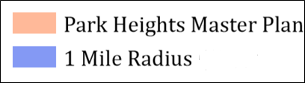

Evaluation Process and Criteria
Projects will be evaluated by Healthy Neighborhoods, Inc. and reviewed and scored by a review panel comprised of members of the PCDA. Competitive Grant applications are reviewed by PCDA members who volunteered to assist with reviews. PCDA’s recommendations for funding are then shared with the Director of Planning/PCDA Chair and the Baltimore City Mayor’s Office who will make the final award decision. To ensure fairness, the committee uses a pre-established rubric to evaluate applications. Applications will be evaluated based on the date of their submission at the corresponding PCDA review session.

Priority:
Projects creating visible, physical change (e.g. capital projects) will be given priority.

Scoring Criteria:
- Impact
- Well thought out proposal
- Number of residents who benefit
- Organizational Capacity and Experience
- Resident Participation and Leadership
- Clearly defined project budget with supporting documentation
- Value and total cost of the project
- Bonus Points: Applicants will receive bonus points for including additional leverage (other funds, materials, and volunteer action), partnerships, and strategic plans.

Successful applications will:
- Be complete and follow application guidelines
- Demonstrate resident participation in the planning, implementation, and leadership of the project
- Create visible and positive community action
- Show careful planning and complete budgets
- Reflect the neighborhood’s ability to implement the proposed project
- Build partnerships with residents, community-based organizations, schools, local institutions, local merchants or others

Requirements Upon Receiving a Grant
If your project is funded, it will be subject to the following requirements:
- Grant Agreement. You will need to prepare and sign a Grant Agreement describing the project and detailing the roles and requirements of all parties BEFORE the project begins.
  - Final Scope and Budget. The Grant Agreement will include a final detailed scope of work, and a final line item budget. It will also include a projected draw schedule, which can be updated over time.
  - Certificate of good standing. Applicants must provide a Certificate from the State of Maryland. The online copy is free and acceptable.
  - Insurance. Baltimore City and/or Healthy Neighborhoods, Inc. may require project insurance.
- Payment Procedures: Healthy Neighborhoods, Inc. will not pay for the full project upfront. Healthy Neighborhoods, Inc. will either reimburse you (or your fiscal sponsor) for expenses as they occur, or directly pay a vendor on your behalf. All payment requests must be accompanied with invoices, paid receipts, and/or other supporting documentation. No future draw requests will be considered until all previous draws are accounted for with payment documentation (i.e., receipts).
- Payment Documentation: At the completion of any awarded project all payment documentation must be submitted to Healthy Neighborhoods, Inc. within 60 days from the day of completion. All organizations affiliated with a project that does not have sufficient documentation for all expenditures within the 60 day timeframe will be prohibited from receiving any future grant funds available through Pimlico Local Impact Aid.
- Reporting: Grant recipients are required to submit reports and photos highlighting their efforts, to make sure that the funds are used as intended. Final payment will be held until a report is submitted.

Large Grant Application

Please select the geographic area of your grant request:
☐ Coldspring Newtown ☐ Liberty-Wabash ☐ NW Community Planning Forum SNAP

Please select each of the following that apply:

I/we understand that individuals or for-profit business may not apply. I/we represent the following (mark all that apply):
☐ 501 (c) (3) non-profit ☐ Neighborhood Association ☐ Community Organization
☐ Faith-based organization ☐ Public or Charter School ☐ Parent Teacher Organization
☐ Government Agency ☐ Other (please specify):

ORGANIZATION PROFILE

Organization Name:
Tax ID Number:
Organization Address:
Organization Phone:
Organization Website:
(if applicable)
Primary Contact Required
Name:
Title:
Phone:
Email:
Secondary Contact Required (Non-Relative)
Name:
Title:
Phone:
Email:
Fiscal Sponsor Contact (If applicable)
Organization Name:
Tax ID Number:
Contact Name & Title:
Organization Phone:

About Your Project

Project name: _______________________________________________________________

Amount requested: $______________ Total project budget: $_______________
(Maximum request = $30,000)

Start and end dates of the proposed project: Start ___________ End _____________

Project Location(s): _______________________________________________________

In what specific neighborhood(s) is your project located? _________________________

Briefly answer the following questions (maximum 3 additional pages, 12 pt. font):

- Briefly describe your organization’s history and mission, the vision it is working toward, and goals to get there. If applicable, please include information about your organization’s Board and strategic goals.

- Please describe your project. What specific issue/challenge do you want to address? Why is this request a priority for your community at this time?

- Describe in detail the project for which your organization is seeking funds. Describe the activities to be undertaken. Who is leading this project? Who is involved? How many adults/youth took part in the planning of the project? Describe the process by which your organization chose this project to address the issue/challenge named in question B.

- Is this a one-time project or an annual project? Is this a new project for your organization or something you have done before? If it has been done before, what impact has it made? How do you plan to sustain an ongoing project?

- For this project, please describe the visible impact it will have in your community. How will this project enhance the physical appearance of your community? What are the anticipated outcomes? How many people will benefit?

Project Budget

List each item in the budget and include the activity and the cost. Please attach a copy of the quote for each item. It can be printed directly from a website or a formal quote.

No more than 10% of the total grant award can be used for administrative costs or fees.

Item | Activity | Cost
Example: Paint and materials for 50 square foot wall mural | Artist will paint golden flowers on the side wall on Art Street | $500.00  ($10 per sq. foot x 50)
1.

2.

3.

4.

5.

Project Schedule

List each project milestone and include the relevant timeline.

Milestone | Timeline
Example: Develop mural concept | 4 weeks
1.

2.

3.

4.

5.

Board Resolution

It is important for the Board of Directors of your organization to be aware of the award and to be committed to completing the project. Please submit a board resolution or equivalent document confirming their approval of the grant and project.

Letters of Support

  - The applicant should submit at least one letter demonstrating community support.
  - An applicant may not submit a letter on its own behalf.
  - If the project appears to lack meaningful community backing, or if other questions emerge during the review process, we may request that you provide additional letters of support.

Bonus Points (optional)
Applicants will receive bonus points for award by providing additional written documentation of leverage, partnerships, and a strategic plan. These documents are not required, but by showing evidence of additional leverage, partnerships, and a strategic plan, the applicant can enhance the application submission. The elevated preference categories are listed below:
- Leverage
- Partnerships
- Strategic Plan
You may complete the information below and/or provide other attachments.

LEVERAGE
If you have support from other groups/people for this project, whether financial, in-kind, donated materials, etc. please list in the chart below. Each form of support listed should include a letter or e-mail from the supporting organization to evidence the additional leverage.

- the contributor’s name – an organization or individual
- form of support – cash, materials, in-kind support
- the monetary value of the contribution

Contributor Name | Form of Support | Value
Example: Annie E. Casey Foundation | Grant from foundation | $5,000.00
1.

2.

3.

4.

Do you have any anticipated sources of support not listed here, or planned fundraising campaigns or events? Please share that information here or on a separate attachment.

______________________________________________________________________________

______________________________________________________________________________

______________________________________________________________________________

______________________________________________________________________________

PARTNERSHIPS
If you have partnerships and participation of city and state agencies, community associations, non-profit organizations, and philanthropic organizations, etc. please list the partner’s name, contact information, and description of their role below. Each form of support listed should include a letter or e-mail from the supporting organization to evidence the partnerships.

- the partner’s name – an organization or individual
- contact information
- description of partner’s role

Partner Name | Partner e-mail and phone number | Dark Hescription of partner’s role
Example: Art Escape | Rob@artescape.org  410-396-9999 | Working in partnership with an arts organization to train youth and develop a concept for a community mural.
1.

2.

3.

4.

STRATEGIC PLAN
Strategic plans are an important part of defining an organization’s role and laying out blueprint for future activities. Grantees will receive bonus points if a strategic plan is included.

Does your organization or association have a strategic plan?

☐ Yes
☐ No
If you checked yes, please attach it as a part of this application to be considered for funding.

OTHER ATTACHMENTS (optional)
You may submit other letters of support, recent newspaper/magazine articles, promotional materials, photographs, architectural plans, and other relevant information not requested above. Please be selective in providing additional attachments and please do not exceed 10 pages.

Applicant Checklist

Application requirements
☐ Geographic Area selection
☐ Organizational Profile (Contact information, tax ID number, and fiscal sponsor if applicable)
☐ About Your Project (name, timeline, location, neighborhood, and questions)
☐ Project Budget
☐ Project Schedule
☐ Board Resolution or Equivalent Document
☐ Letters of Support

Bonus Points (optional)
☐ Leverage (additional funding, materials, and volunteer action) and documentation from the supporting organization to evidence the additional support
☐ Partnerships, including documentation from the supporting organization to evidence the additional partnerships
☐ Strategic Plan

Other Attachments (optional)
☐ Other attachments, including additional letters of support, recent newspaper/magazine articles, promotional materials, photographs, architectural plans, and other relevant information not requested in the application. Not to exceed 10 pages.

Applications should be returned to Healthy Neighborhoods, Inc.

Email your completed application and all attachments to:
Matthew Bartolini Mark Sissman
mbartolini@healthyneighborhoods.org msissman@healthyneighborhoods.org
410-332-0387 ext. 1004 410-332-0387 ext. 1001

Or mail your completed application and all attachments to:
Healthy Neighborhoods, Inc.
Attn: Matthew Bartolini
11 East Mount Royal Avenue, Suite 302
Baltimore, MD 21202

Park Heights Master Plan area. For information about funding in the Park Heights Master Plan area, please contact Park Heights Renaissance (info@phrmd.org; 410-664-4890).

